In this lab, we’re going to examine how lenses and mirrors work with the ray model of light.

Part 1: Converging and Diverging Lens Simulations
In order to examine ray tracing diagrams, and we will look at how varying object distances and sizes – as well as varying focal lengths – changes the size, orientation, and location of a focused image. The simulation for the behavior of a “thin lens” can be found here:
http://physics.bu.edu/~duffy/HTML5/Lenses.html
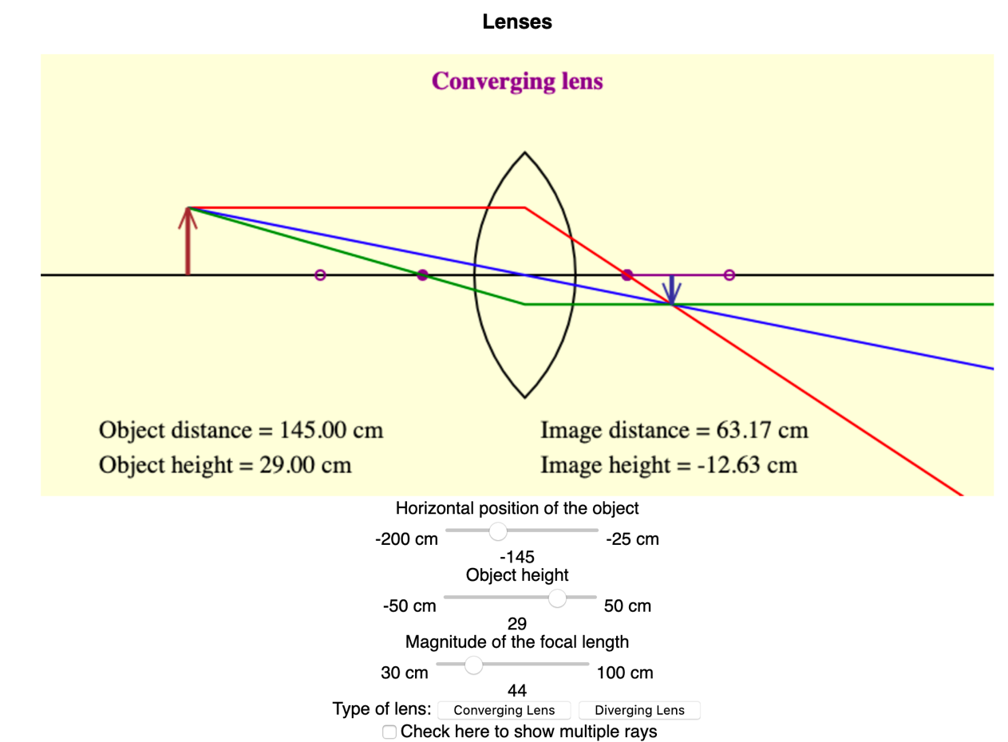
Type of lens
Distance from center of lens to object
Height of object
Focal length

You should remember to use the sign conventions listed in the reading when doing calculations in this lab. The simulation tends to use negative signs (on the object distance, for example) for things that are on the left, even when that doesn’t match those sign conventions.

For a Converging Lens:
- Click the “Converging Lens” button. As you move the focal length of the lens from its smallest value to its largest, leave the object distance and the object height the same.
  - What happens to the image distance?
  - What happens to the image height?
- Now set the focal length to f = 65 cm. For each of the following, where the questions ask you “what happens to the image” you should say whether the image gets larger or smaller through the range indicated; what happens to the location of the image; is the image upright, or inverted?
 | Object distance decreases from maximum to 2f | Object distance decreases from 2f to f | Object distance decreases from f to minimum
Does the image height get larger or smaller as the focal length decreases?
Does the image distance get larger or smaller as the focal length decreases?
Is the image upright or inverted?

For a Diverging Lens:
- Click the “Diverging Lens” button, and reset the object distance to be in the center of its range. Then, as you move the focal length of the lens from its smallest value to its largest, leave the object distance and the object height the same.
  - What happens to the image distance?
  - What happens to the image height?
- Now set the focal length to f = 65 cm. For each of the following, where the questions ask you “what happens to the image” you should say whether the image gets larger or smaller through the range indicated; what happens to the location of the image; is the image upright, or inverted?
 | Object distance decreases from maximum to 2f | Object distance decreases from 2f to f | Object distance decreases from f to minimum
Does the image height get larger or smaller as the focal length decreases?
Does the image distance get larger or smaller as the focal length decreases?
Is the image upright or inverted?

Part 2: Converging and Diverging Mirror Simulations
We will use the simulation at the following site to look at ray diagrams for mirrors:
http://physics.bu.edu/~duffy/HTML5/Mirrors.html
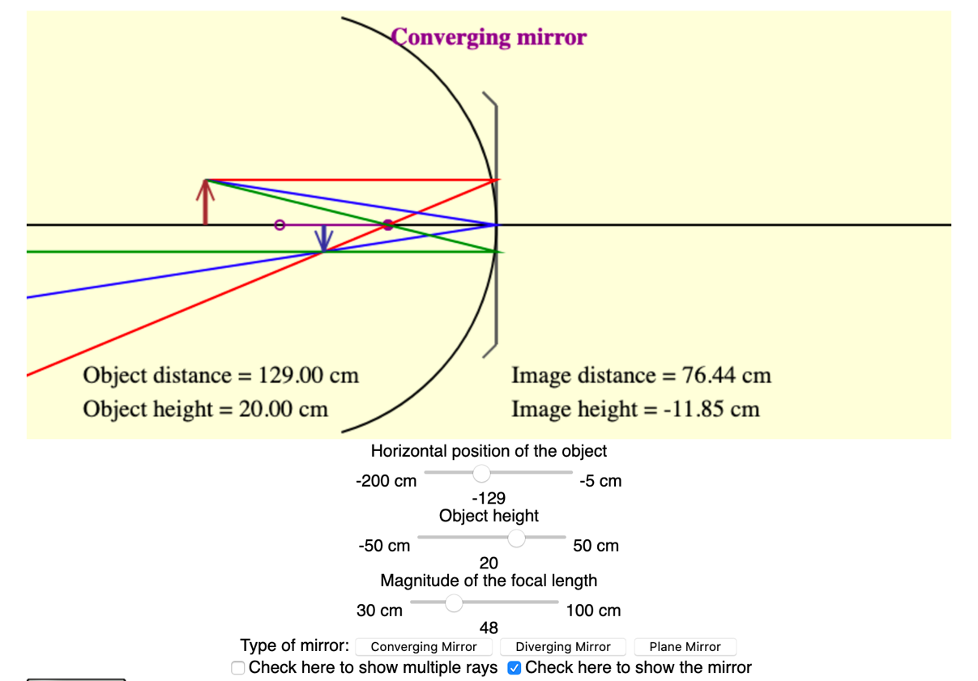
Focal length
Object height
Object distance
To make the curve of the mirror show
Type of mirror

You should remember to use the sign conventions listed in the reading when doing calculations in this lab. The simulation tends to use negative signs (on the object distance, for example) for things that are on the left, even when that doesn’t match those sign conventions.

For a Converging Mirror:
- Click the “Converging Mirror” button, and reset the object distance to be in the center of its range. As you move the focal length of the mirror from its smallest value to its largest, leave the object distance and the object height the same.
  - What happens to the image distance?
  - What happens to the image height?
- Now set the focal length to f = 65 cm. For each of the following, where the questions ask you “what happens to the image” you should say whether the image gets larger or smaller through the range indicated; what happens to the location of the image; is the image upright, or inverted?
 | Object distance decreases from maximum to 2f | Object distance decreases from 2f to f | Object distance decreases from f to minimum
Does the image height get larger or smaller as the focal length decreases?
Does the image distance get larger or smaller as the focal length decreases?
Is the image upright or inverted?

For a Diverging Mirror:
- Click the “Diverging Mirror” button and reset the object distance to be in the center of its range. As you move the focal length of the mirror from its smallest value to its largest, leave the object distance and the object height the same.
  - What happens to the image distance?
  - What happens to the image height?

- Now set the focal length to f = 65 cm. For each of the following, where the questions ask you “what happens to the image” you should say whether the image gets larger or smaller through the range indicated; what happens to the location of the image; is the image upright, or inverted?
 | Object distance decreases from maximum to 2f | Object distance decreases from 2f to f | Object distance decreases from f to minimum
Does the image height get larger or smaller as the focal length decreases?
Does the image distance get larger or smaller as the focal length decreases?
Is the image upright or inverted?

- Summarize your findings from Parts 1-2 by filling out the table below.
 | Object Distance | Image Height: Larger/Smaller than object? | Orientation: Flipped or Upright? | Image Type: Real or Virtual?
Converging Lenses | $$d_{o}>2f$$
Converging Lenses | $$2f<d_{o}<f$$
Converging Lenses | $$d_{o}<f$$
Diverging Lenses | All
Part 3: Calculating focal length and magnification for converging and diverging lenses
- For several converging lenses, you are given the following object and image distances. Show your calculations, using the thin lens equation and the magnification equation.
Object distance (cm) | Image distance (cm) | Focal length (cm) | Magnification | Flipped or upright? | Image larger or smaller than object?
28 | -80
119 | 159
187 | 163

- For several diverging lenses, you are given the following object and image distances. Show your calculations, using the thin lens equation and the magnification equation.
Object distance (cm) | Image distance (cm) | Focal length (cm) | Magnification | Flipped or upright? | Image larger or smaller than object?
30 | -7.5
24 | -11.2
28 | -17.1

Part 4: Calculating focal length and magnification for converging and diverging mirrors
- For several converging mirrors, you are given the following object and image distances. Show your calculations, using the thin lens equation and the magnification equation.
Object distance (cm) | Image distance (cm) | Focal length (cm) | Magnification | Flipped or upright? | Image larger or smaller than object?
28 | -80
35 | 169
19 | 17.1

- For several diverging mirrors, you are given the following object and image distances. Show your calculations, using the thin lens equation and the magnification equation.
Object distance (cm) | Image distance (cm) | Focal length (cm) | Magnification | Flipped or upright? | Image larger or smaller than object?
33 | -20.2
30 | -13.0
25 | -8.1

